REFLECTED CROSS-SITE SCRIPTING (XSS) REPORT

Name: | Matchoffo Lepe Miran
Track: | Networking and Cyber Security

1. Objective
To identify and demonstrate a Reflected Cross-Site Scripting (XSS) vulnerability in DVWA using a harmless JavaScript alert payload.

2. system used
- Operating System: Kali Linux
- Virtualization: VirtualBox
- Vulnerable Application: DVWA
- Browser: Firefox
- DVWA Security Level: Low
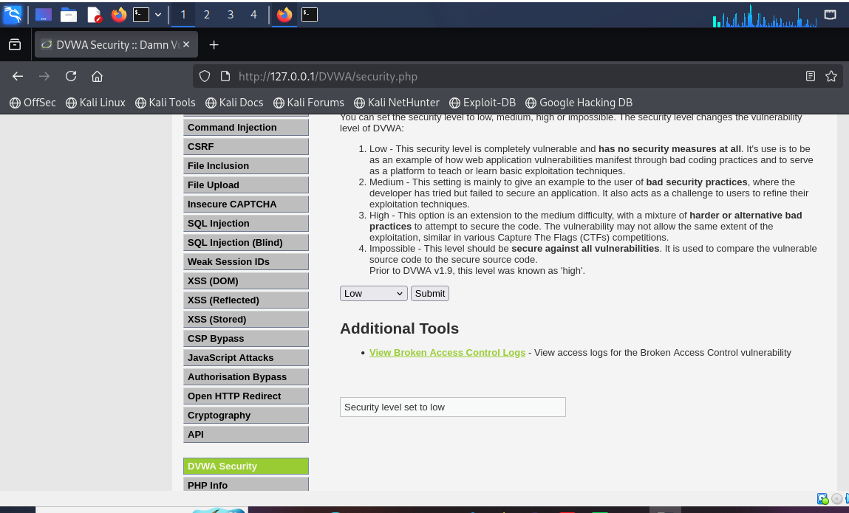

3. Procedure
The DVWA XSS (Reflected) module was opened.
First, normal input was tested:
Miran
The application reflected the input back to the page.
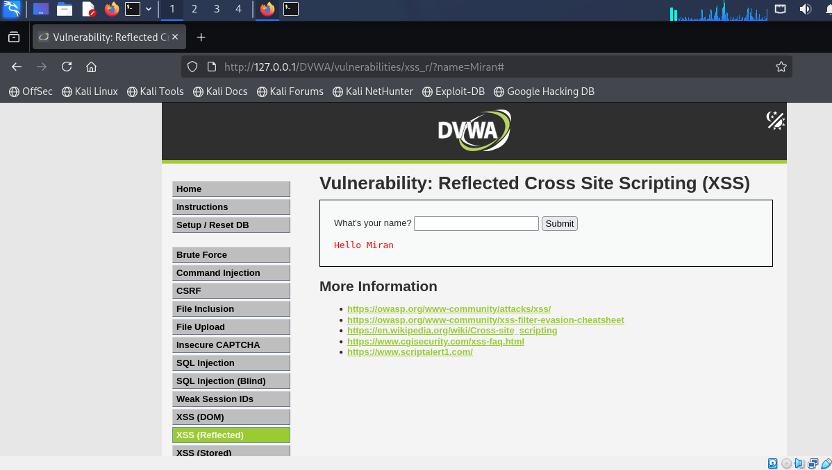

Next, a harmless XSS test payload was entered:
<script>alert('XSS Test')</script>
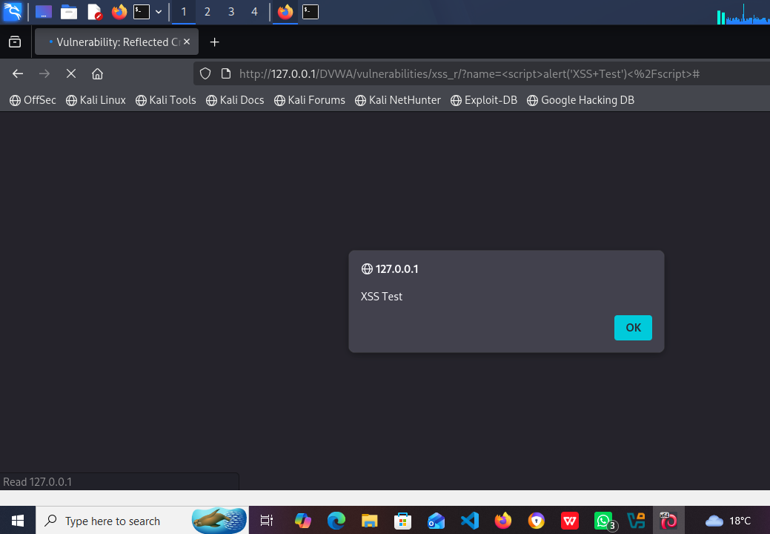
After submitting the input, a JavaScript alert box appeared in the browser.

This confirmed that the application was vulnerable to Reflected XSS.

4. Finding
The application reflected user-controlled input back into the web page without proper output encoding. As a result, the browser interpreted the injected input as executable content instead of plain text.
The input was reflected immediately and was not permanently stored, confirming that this was a Reflected XSS vulnerability.
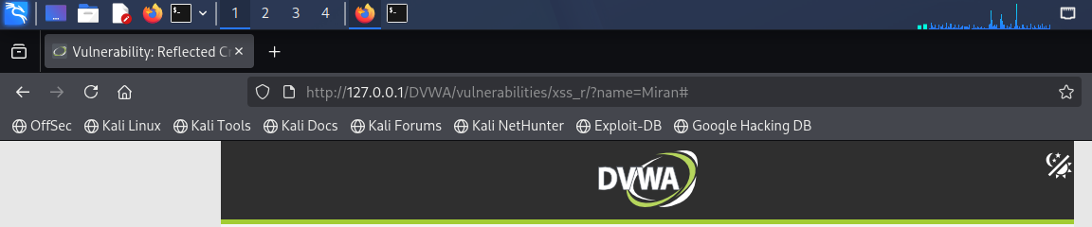
Figure 1

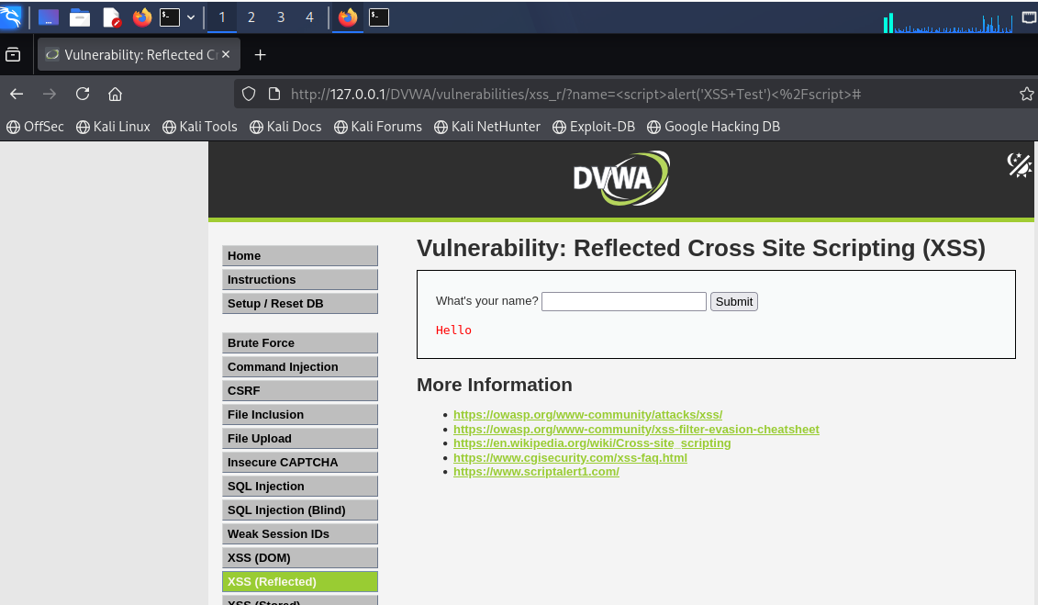
Figure 2

5. Root Cause
The root cause was a lack of proper context-aware output encoding.
The type of encoding required depends on where the input appears:
- HTML Context: Use HTML encoding.
- Attribute Context: Use attribute encoding.
- JavaScript Context: Use JavaScript-safe encoding.

6. Security Impact
Reflected XSS can allow unauthorized JavaScript to execute in a user's browser when they visit a vulnerable request. This can lead to phishing, unauthorized actions, or exposure of sensitive information depending on the application's security controls.

7. Remediation
The following measures are recommended:
- Apply context-aware output encoding.
- Validate user input.
- Avoid unsafe insertion of untrusted data.
- Implement Content Security Policy (CSP).
- Use secure cookie settings such as HttpOnly, Secure, and SameSite.

8. Conclusion
A Reflected XSS vulnerability was successfully demonstrated in the DVWA lab environment. The harmless JavaScript alert confirmed that untrusted input could be reflected and interpreted as executable content. Proper output encoding and secure coding practices are necessary to prevent this vulnerability.

